
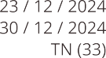
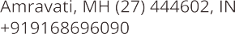
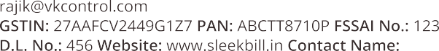

M K Trading Co
66, Charlie Apartments, Kharadi Bikaner - 181415

+91 06 85892863
dnigam@gmail.com
xxxxxxxxxx mktrading.com
Naval Ghosh
8HIMAL9524K6Z6



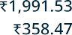


Naval Ghosh SBI Bikaner
 | 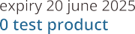  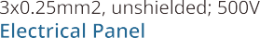 |  | 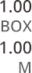 |  |  | 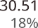  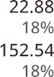  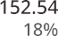

xxxxxxxxxxx
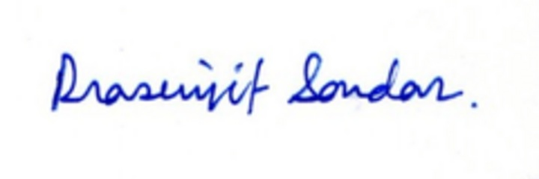
Bikaner xxxxxxxxxx
M K Trading

